Chapter 2 Cells
Name: Class: Date:
extra worksheet 3: Plant systems
Science understanding Visual/Spatial

Cells, tissues and organs
Figures 1 and 2 below show images of parts of plants taken through a microscope. Photographs taken in this way are known as photomicrographs.
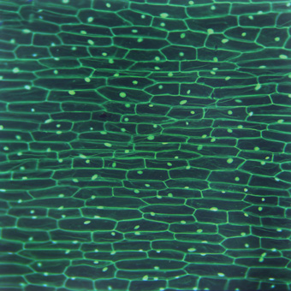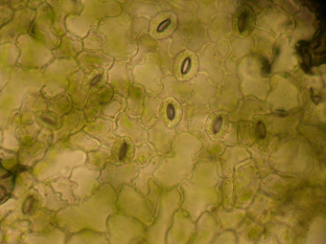
Figure 1 Figure 2
1 a Deduce whether Figure 1 is a photomicrograph of a cell, tissue or organ.

b Justify your conclusion.

2 a Deduce whether Figure 2 is a photomicrograph of a cell, a tissue or an organ.

b Justify your conclusion.

Figure 3 below is a photomicrograph of a plant stem. The stem has been cut across as if cutting off a flower. If the complete stem could be seen it would appear as a circle.

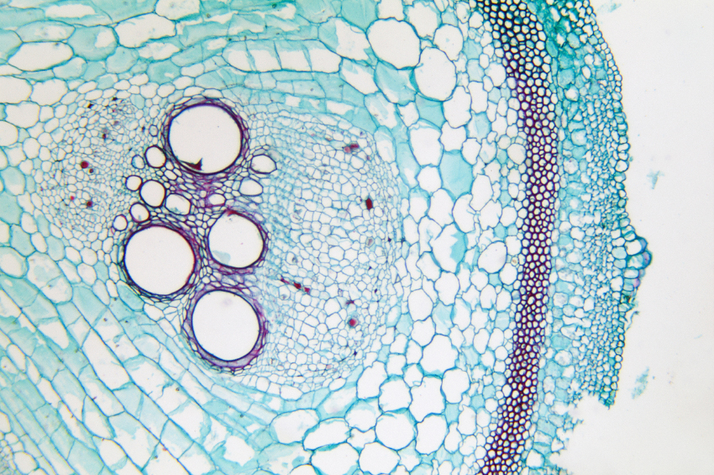
X
Figure 3
3 The stem is a plant organ. Select the information from the photomicrograph that supports this statement.

4 a Draw an arrow on Figure 3 pointing to the part of the stem that is most likely to be the cells that carry water from the roots to the shoots.
b Justify why you placed the arrow in that position.

5 a Propose a function of the layer of cells marked with an X in Figure 3.

b Justify your answer.

Plant pathways
Figure 4 below is a leaf with the veins clearly showing.
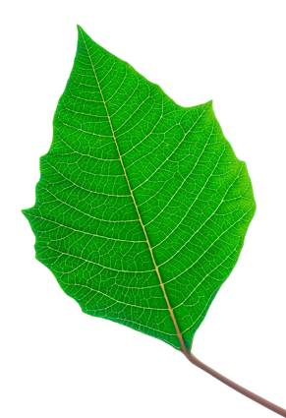
Figure 4
6 Draw red arrows on Figure 4 to show the pathway of water through the leaf.
7 Draw blue arrows on Figure 4 to show the pathway of food through the leaf.

